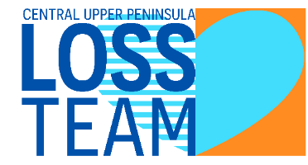
LOSS TEAM VOLUNTEER INTEREST FORM
First and Last Name: ____________________________________________________________
Address/City/Zip: _______________________________________________________________
Phone Number: ________________________________________ Cell Home Work
Phone Number: ________________________________________ Cell Home Work
Why are you interested in joining the LOSS Team? ____________________________________
_____________________________________________________________________________
Check all areas that define yourself:
Loss Survivor Relationship: _______________ Month/year_________________
Coroner Mental Health Professional Clergy/Faith-Based
Youth/Student Education Law Enforcement Government
Social Services Other: ____________________________________________________

If you are a loss survivor, what have you done to help yourself in the grieving process?
Individual Therapy Survivors of Suicide Group Other: ________________

Check all suicide prevention training you have completed:
ASIST SAFE TALK CAMS QPR AFSP CLINICIAN
AMSR SOUL SHOP PSYCHOLOGICAL FIRST AID

MENTAL HEALTH FIRST AID OTHER_________

How did you hear about the LOSS Team? ___________________________________________

Signature: ______________________________________ Date: _________________________
Attending the volunteer LOSS Team training does not automatically authorize you to be on the LOSS Team. You are required to complete an interview, suicide prevention, and LOSS Team training. It is recommended loss survivors are 18 to 24 months past the loss of their loved one.
Please send completed form to LOSS@greatlakesrecovery.org.

